
AVZ Briefing - Value of preventing road collisions, Great Britain (2024)
28 Oct 2025

Key points
Total cost
- The Department for Transport’s (DfT) total estimated value of prevention of road collisions in Great Britain rose to almost £55 billion in 2024; an increase of 30% from 2023.
- The rise was due to casualty collisions not reported to police, which rose by 50% to £36 billion.
Share of total value by collision severity
- Unreported casualty collisions accounted for almost two-thirds (65%) of the estimated total value.
- Fatal crashes account for 8% and (reported) serious injury collisions 14%.
Share of total value by cost elements
- See Table 2 overleaf for how each cost element contributed to the total valuation.
- Over two-thirds (68%) of the estimated value comes from the Human costs element.
- Most of the Human costs element is with unreported casualty crashes.
Average cost
- The average cost of fatal crash rose to £2.8 million; a rise of 4% from 2023.
- Fatal crashes have an average cost almost nine times higher than a serious injury collision (£325k), whilst an average serious injury collision is 10 times that of an average slight injury collision (£33k).
- Average costs do not include an adjustment for under-reporting, despite unreported casualty crashes accounting for so much of the total value of prevention.

Table 1: Value of preventing road collisions, Great Britain
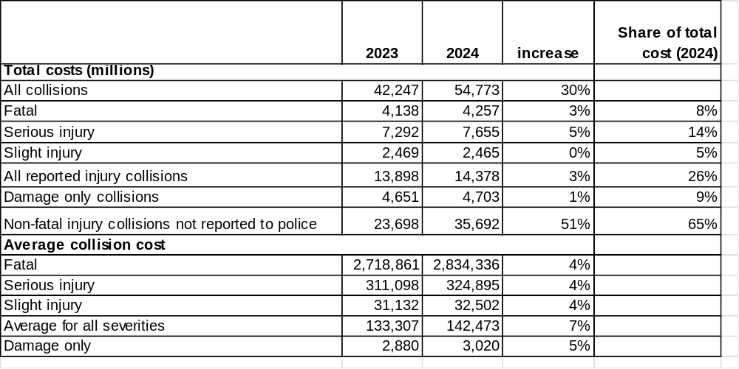Source: DfT (2025), RAS4001: Cost of prevention of road collisions and casualties
AVZ comment: Unreported casualty collisions account for almost two-thirds of the total estimated cost of preventing road collisions in Great Britain. Yet average costs of prevention, used to justify safety schemes, do not include an adjustment for unreported casualty collisions. Road safety measures are being under-valued. Average values should be inflated to reflect the true toll from road collisions. More consideration should be given to unreported road collisions, given their scale and economic impact, including with regional estimates.
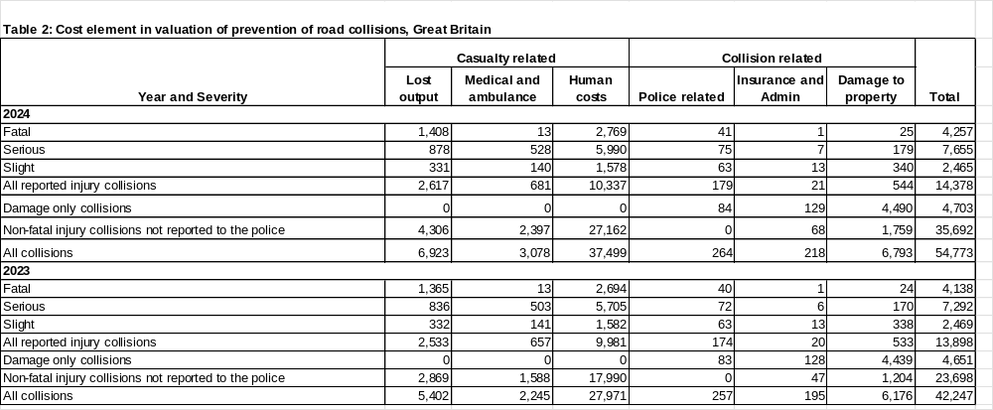
Source: DfT (2025), RAS4001: Cost of prevention of road collisions and casualties

The value of prevention is not the same as direct economic costs as it includes an estimate of the human costs.
The Human costs element is based on the Willingness to Pay approach.

