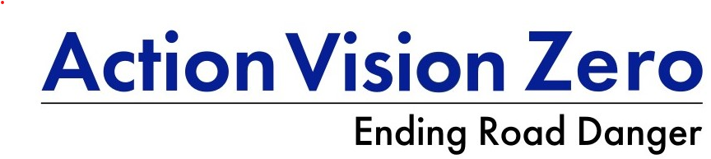
Speed enforcement in London
AVZ update
10 July 2026

Key points
- Speed enforcement in London has soared in recent years, reaching 821k in 2024 according to the London Vision Zero Enforcement Dashboard (LVZED), which includes offences started and later cancelled.
- It has risen fastest on 20 mph roads—up 10fold between 2018 and 2025, according to the LVZED.
- But London has a problem with cancelled speeding tickets (40%) and LVZED reports a decrease in speeding offences in 2025.
- Speed enforcement should be increasing under the new London Vision Zero Action Plan 2.
- And much more is needed. When compared with other police services, on the number of speeding offences per Killed and Seriously Injured (KSI), the Metropolitan Police (Met) was 13th out of 43 police services (2024), and would have to double its output to come second.

Data sources
Data is from three sources: Home Office (HO), Ministry of Justice (MoJ), and the LVZED. The latter is London specific and includes offences which are later cancelled but it does show data by speed limit (unlike the HO or MoJ). The MoJ data is on those offences prosecuted at court whilst the Home Office reports those out of court, i.e. the vast majority of speed offences.

Total speed limit offences
According to the Home Office (HO), in 2024:
- Of the 821k speed limit offences initially reported by the Met, 330k were cancelled, leaving 492k speed limit offences reported.
- This was 82% of total motoring offences reported by the Met, and almost 13 times the next most common offence, Neglect of Traffic Directions (64k).
- 99% of speed limit offences were camera detected.
The preliminary 2025 data from the LVZED show that
- Speed limit offences are down 10% from 2024.
- 13,660 vehicles were detected speeding by Community Speed Watch with 11,881 letters sent.

Outcome (HO and MoJ)
- The high cancellation rate (40%) is partly attributed to the number of emergency service and diplomatic vehicles in the city. It is not known if certain speed limits had higher cancellation rates than others.
Excluding those cancelled:
- Over half (52%)—255k were offered National Driver Offender Retraining Scheme
- 37% --15k—were given a Fixed Penalty Notice (£100 fine and three penalty points)
- 10% --50k--were referred to court for prosecution
- Of those convicted at court (97%),
  - The average fine was £269, down from £320 in 2024
  - just 2% were banned in 2024 but this doubled in 2025 to 4%.
  - Another 2.2k were given a ban for totting up with speeding offences in 2025.

Trend and target
- Speed limit offences had increased fivefold by 2024 compared to 2018 when the first London Vision Zero Action Plan was launched.
- The London Vision Zero Action Plan Progress Report (2021) set a target of one million speed limit offences (including cancelled). This was not met.

Which roads (speed limit) (TfL/MPS)
Speed enforcement has increased greatly on 20 mph roads (over tenfold) and accounted for over half of total speed offences in 2025 (53%). But TfL reports 63% of KSIs occur on 20 mph roads, and 93% KSI on 20 and 30 mph roads, compared to 74% speed offences. So an even higher share could be justified. AVZ has campaigned for more enforcement on 20 and 30mph roads.

Table 1: London Speed limit offences by speed limit (including cancelled offences)
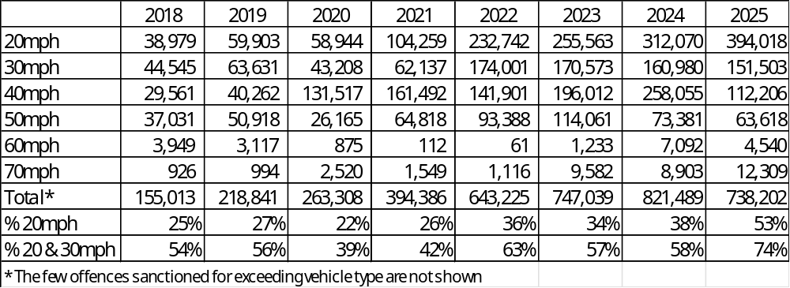
Source: LVZED (2025)

Compared to other police services
- Despite the large increase in speed enforcement, the Met does not lead the country in speed enforcement. When compared on a per KSI basis, the Met was 13th out of the 43 police services, with 135 speed offences per KSI. Warwickshire reported 423 per KSI and Devon and Cornwall had 255. So the Met would have to double their speed offences to qualify for second place.

Going forward—London Vision Zero Action Plan
- Whilst a speed enforcement target was not maintained in the London Vision Zero Action Plan 2, launched in March 2026, the plan does prioritise speed enforcement, including:
  - Upgrading the extensive camera network (over 700)
  - Developing joint action plan on speed compliance with police and boroughs
  - Expanding the role of Police Community Support Officers in speed enforcement.
  - Intention to introduce a speed compliance map

What else?
AVZ believes there is even more that London can do to tackle speeding:
- Reduce the cancellation rate and increase speed enforcement even more, especially on 20 mph roads where the vast majority of pedestrian and cyclist KSIs occur.
- Ban more extreme speeders. London should aim to lead the country.
- Improve transparency with the LVZED showing offences by borough, as long promised.
- Reduce the burden on speed enforcement with the wider promotion, if not requirement, of Intelligent Speed Assistance (ISA) in government contracts and borough fleets.
- Lobby for speeding penalties to be increased (last updated in 2016) and for consideration of Dutch decriminalised approach which delivers much more enforcement and has heavier fines for built-up areas.

Table 2: London reported KSIs
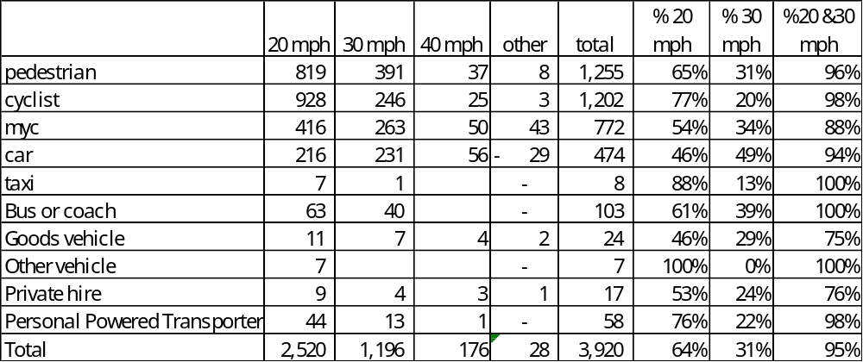
Source: TfL Road Danger Reduction Dashboard (2026)

Table 3: Home Office Speed limit offences, Metropolitan Police
 | 2018 | 2019 | 2020 | 2021 | 2022 | 2023 | 2024 | 2018-2024 increase
Cancelled | 46,547 | 66,504 | 75,290 | 116,636 | 218,060 | 346,518 | 329,622 | 608%
Court Action | 25,320 | 23,763 | 33,951 | 36,255 | 50,169 | 39,696 | 50,109 | 98%
Driver Retraining | 43,411 | 74,086 | 93,964 | 139,860 | 227,902 | 236,453 | 254,867 | 487%
Fine Paid | 28,846 | 40,239 | 44,310 | 68,681 | 102,565 | 117,084 | 134,994 | 368%
Incomplete | 2 | 359 | 0 | 1,084 | 2 | 0 | 51,858
Total | 144,126 | 204,951 | 247,515 | 362,516 | 598,698 | 739,751 | 821,450 | 470%
Total excluding cancelled | 97,579 | 138,447 | 172,225 | 245,880 | 380,638 | 393,233 | 491,828 | 404%
Source: HO (2026)

Sources
HO (2026), Fixed penalty notices (FPNs) and other outcomes for motoring offences statistics
Police powers and procedures: roads policing, to December 2024
MoJ (2026), Criminal Justice Statistics quarterly: December 2025
TfL (2026), London Vision Zero Enforcement Dashboard
TfL (2026), London Road Danger Reduction Dashboard

