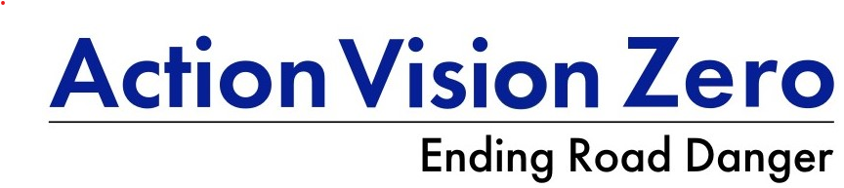

Public reporting and the Met
15 July 2026 update

Key points (2025)
- The 23k submissions received was down 10% from the high of over 25k in 2024.
- Two offences accounted for three of four reports:
  - Careless driving accounted (46%)
  - Use of mobile phone whilst driving (29%)
- But few careless driving reports result in a sanction being recommended (24%) whilst this rose to 46% for mobile phone reports.
- Compared to other large police services, the Met has low submissions and a low sanction rate, especially with careless driving.
- The new London Vision Zero Action Plan 2 priority actions include “Increase dashcam and helmet camera reporting” and this should also include increasing the sanction rate.

The Met has recently published performance data on its public reporting scheme, covering from 2023 through to March 2026. Data includes the offence code and description, date, disposal, No Further Action (NFA) reason, month, year, and location, but location can be a road name or just “London”. Fields for vehicle make and model are also included but are almost always “Not Stated”.

Number of submissions and offences (Table 1)
In 2025, the 22,988 submissions received was 10% lower than the 25,441 in 2024 or the 24,733 in 2023. Based on the first quarter of the year, the decrease in reports received looks to continue.

With some 70 offences reported, two account for almost three-quarters of all submissions (74%).
Careless driving accounted for 46% and mobile phone offences 29%. These two offences dominated each of the years in the dataset.

Recommended outcomes (2025) (Tables 2-4)
Disposal refers to the outcome recommended by the public reporting team. ‘Sent for court’ does not guarantee it will be heard at court as this will be the decision of the prosecution team.

After excluding those transferred and ongoing, of the 21,715 remaining, the recommended outcomes included:
- One-third of submissions (33%) sanctioned (i.e. FPN paid, retraining course or sent for court prosecution), including 13% being sent for court prosecution.
- With information and advisory letters included, over half had a positive action (52%).

Careless driving submissions had a lower success rate. Their sanction rate was only 24% so less than one in four resulted in a recommended sanction, including 8% being proposed for prosecution at court. With many reports resulting in an information or advisory letter, the positive action was 43%.

Mobile phone reports were more successful, with almost half resulting to a sanction being recommended (46%). Driver retraining course is not used by the Met with mobile phone reports and 19% were recommended for prosecution. With information and advisory letters, the positive action rate was 71%.

NFA reason
The dataset includes reasons for No Further Action. But in over half, the reason was left blank (55%) whilst “Evidence not met for prosecution” accounted for 33%. With careless driving allegations, the evidence was not good enough in 39% reports, whilst this was only 21% with mobile phone NFAs.

Comparison with other police services
Despite its size, the Met does not receive as many reports as do the West Midlands Police. The most recent data from the West Midlands Police (Mar-Apr 2026) shows a monthly average of over 2200 reports, compared to a monthly average of 1916 for the Met in the first quarter of 2026.

Careless driving reports were again the most common in the West Midlands (38%) but there they had a sanction rate of 47%, almost twice that of the Met. And in West Yorkshire, where half as many reports were received in 2025 than in London, they sanctioned 4543 careless driving reports, almost twice that as the Met.

Better should be coming
The new London Vision Zero Action Plan 2 highlighted 19 priority actions, one of which was to “Increase dashcam and helmet camera reporting “. More was included in the chapter on Safe Behaviours as shown below. And while the commitment to expanding capacity and making it easier to report is appreciated, there also needs to be priority given to improving the sanction rate, especially with careless driving. Dangerous driving did not appear in any of the 80k reports in the Met dataset whilst careless driving accounted for over 40% of the reports submitted.

London Vision Zero Action Plan Safe Behaviours
Expanding the reach of police enforcement
Too many Londoners still believe they won’t be caught breaking road traffic laws. To challenge this perception and address poor road-user behaviour, we will expand public reporting capacity, making it easier for people to submit evidence of dangerous driving using dashcams and helmet cameras. This supports a culture of zero-tolerance for reckless behaviour.

While police officers cannot be everywhere, the public can play an important role in identifying risk and supporting enforcement. Intelligence-led policing already targets the highest-risk road users, and public reporting helps to bridge remaining gaps.

With around a third of drivers now using in-vehicle or wearable cameras, there is growing potential to strengthen accountability, remove the most dangerous drivers from London’s roads, and contribute to safer streets and stronger community confidence

Footage submitted online is helping to build a clearer picture of high-risk behaviours, locations and individuals. We want to grow our enforcement capability and make it clear to drivers that unsafe driving will be caught and dealt with. By empowering the public to report dangerous behaviour, we are not only expanding our enforcement reach, we are also fostering a culture where safety is prioritised and risk is rejected.

Table 1: Public reports, Met Police
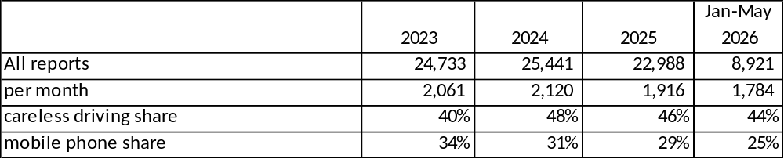

Table 2: Outcomes of all public reports, Met Police
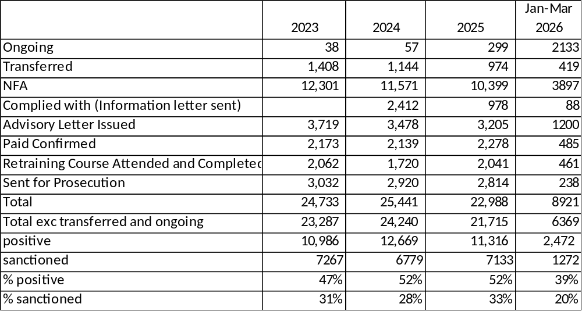

Table 3: Careless driving report outcomes, Met Police
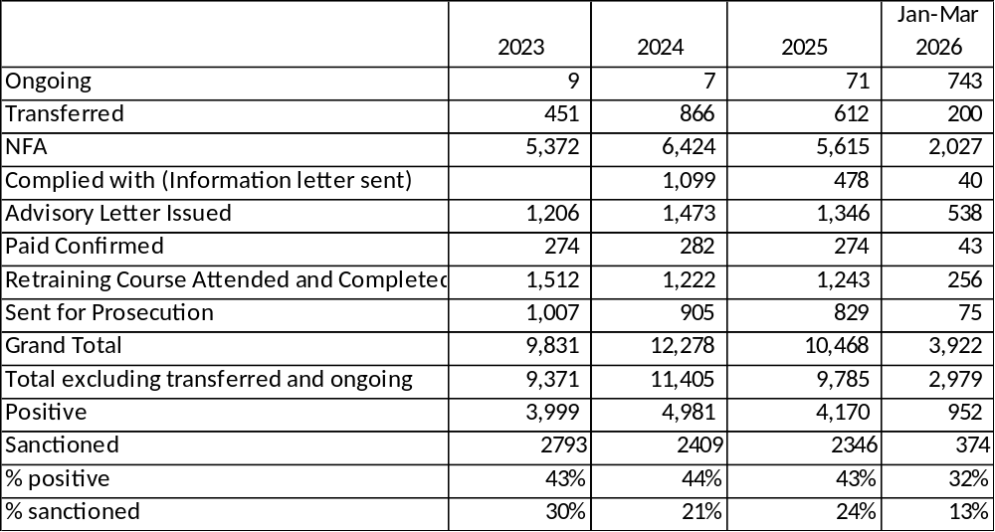

Table 4: Mobile phone report outcomes, Met Police
