
Sentencing Council Strategic Objectives
2026-2030 consultation
AVZ response DRAFT
14 Oct 2026

Question 1: What is your name?
Amy Aeron-Thomas

Question 2: What is your email address?
Amy@ActionVisionZero.org

Question 3: Are you answering as an individual? If so, are you happy for your name to be included in the consultation response document?
Not as individual

Question 4: If you are answering on behalf of an organisation, group or bench, please provide the name of the organisation, group or bench.
Action Vision Zero

This response is submitted on behalf of Action Vision Zero (AVZ), as part of our efforts to improve the justice system’s response to road danger and reduce harm posed to people walking and cycling.

Question 5: Do you agree that the Council’s focus for guidelines should shift to evaluation, revision and maintenance?
Yes

Question 6: Are the projects listed above the right ones?
No. None of the proposed projects relate to motoring offences, despite motoring offences accounting for over 60% of sentences at court. See Table 1 below.

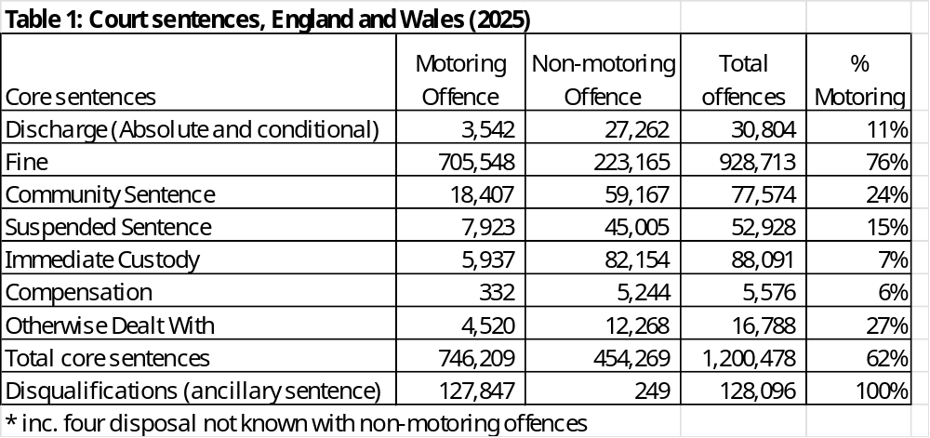
Source: MoJ (2026)

Disqualifications and (other) non custodial sentences for motoring offences should be added as a project. This should include vehicle confiscation, compensation, and home curfews.
This is needed as the Sentencing Act introduced a presumption against short custodial sentences, i.e. prison sentences of 12 months and under will not be given except for specific high risk cases. As 77% of custodial sentences given to motoring offences in 2025, there is a real need to think about non-custodial sentences.

More focus should be on rehabilitation, a key aim of sentencing. At present only drink driving offences have a rehabilitation option and they account for less than 4% of motoring offences sentenced at court.

Rehabilitation is used with offences sanctioned out of court. Of the 3.5 million offences reported by the Home Office (excluding cancelled), half are sent on a driver retraining scheme (51%), whilst another 10% were referred to court and a third paid a FPN (34%). (Home Office, 2026).

Question 7: Are there other offences or areas on which consultees would like to see new or revised sentencing guidelines?
Serious motoring offences (Causing death and serious injury by driving offences and Dangerous Driving) were updated in 2023 and Careless Driving in 2025. The Disqualification Guideline was introduced in 2024.

But the Speeding Sentencing Guidelines was last revised in 2017. Speeding is also the most common offence sentenced at court, and at 214k, accounted for over one in six offences sentenced at court in 2025. (MoJ, 2026).

Question 8: Are there any other areas of analysis and research that the Council should look into?
The use of disqualification merits analysis and research. AVZ does not think it is being used properly, including with
- totting up bans
- speeding bans
- careless driving bans
- ban duration

Totting up bans
The Council strengthened their guidance on totting up bans in 2020 and clarified that impact on the driver’s employment did not qualify as exceptional hardship (only if family or employees were affected). But this does not appear to have the desired effect of ensuring exceptional hardship pleas were only successful when exceptional.

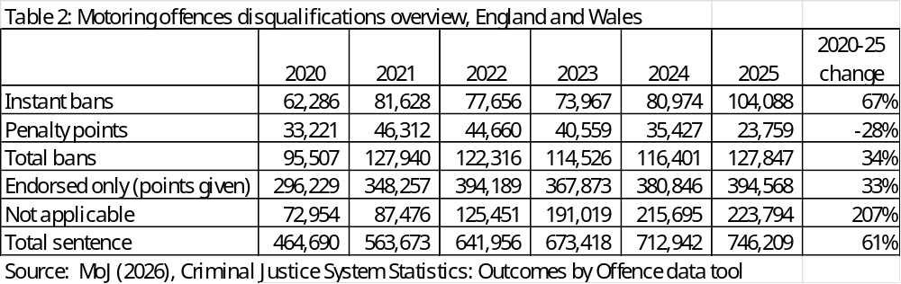

As shown above in Table 2, the number of penalty points has fallen by 28% since 2020, whilst total sentences have increased by 61% and instant bans by 67%. Nor is the decline in totting up bans is down to a decrease in offences being sanctioned out of court. Between 2020-2024, the Home Office reported an increase of 49% motoring offences sanctioned.

Speeding bans
In 2025, the number of speeding offences resulting in a ban doubled to almost 4% (excluding totting up bans).

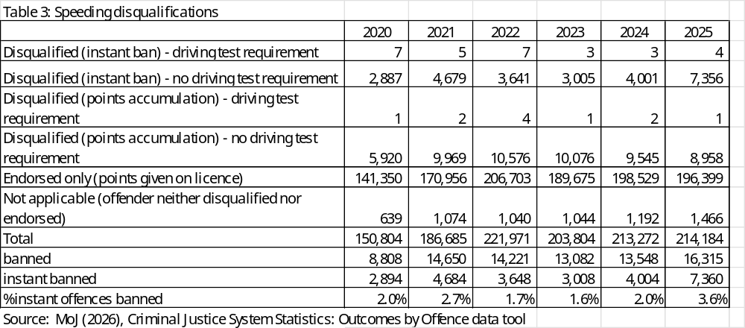

Just 10% speeding offences sanctioned are convicted at court. These will include the worst offenders summonsed to court for high levels of speeding. Under the current sentencing guidelines for speeding, magistrates are supposed to consider disqualification if the driver was doing more than 31 in a 20 mph and 41 in a 30 mph speed limit. Yet, as shown in Table 4, police guidance only recommends court prosecutions above these speeds.

Table 4: NPCC speed enforcement guidance and Speeding Sentencing Guidelines.
Speed limit | NPCC guidance | Sentencing Guidelines
Speed limit | court summons | Disqualify for -28 days  OR 4-6 points | Disqualify for 56 days  OR 6 points
20mph | 35mph | 31-40mph | 41mph and above
30mph | 50mph | 41-50mph | 5mph1 and above
Source: NPCC (2025), Sentencing Council (2017)

Based on the above, AVZ believes most drivers convicted at court for speeding should qualify for consideration for disqualification. The length of instant bans for speeding should also be reviewed as these are very short.

Careless driving bans
In July 2025, Careless driving sentencing guideline was updated and one key change was that disqualification was to be considered with offences of medium culpability (in addition to high culpability). And whilst instant bans did increase in 2025, they were still only being used with 6% of those convicted.

And as shown below in Table 5, many careless driving prosecutions did not start out as careless driving reported by the Home Office. The Home Office stats do not include arrests These are assumed to be dangerous driving arrests which were subsequently downgraded to careless driving prosecutions. These should be high level culpability and merited disqualification.

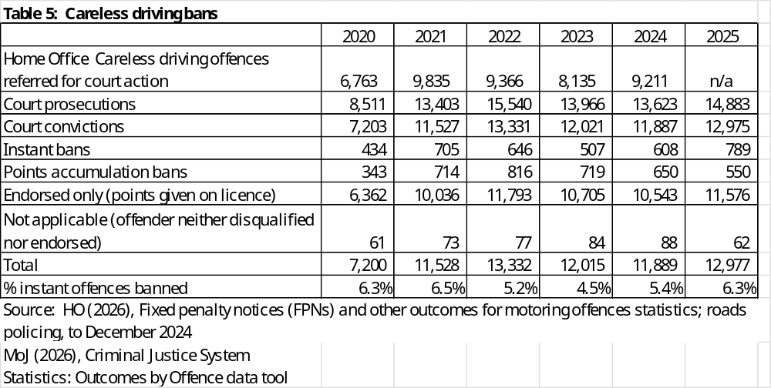

Ban duration
Research could also review why lifetime bans are not being given for the worst offenders. In 2025 there were only 11 lifetime bans given, including two for Causing Death by Dangerous Driving, two for Causing Death by Careless Driving and seven for Dangerous Driving.

Question 9: Are there any other sources of quantitative or qualitative evidence that the Council could use that are not mentioned above?
Magistrates could be surveyed as to why they do not give more bans for speeding and careless driving and why they accept exceptional hardship pleas.

Totting up disqualifications. The Council could look at the number of successful pleas made for exceptional hardship. This data is not published and AVZ’s FOI has been refused.

Speeding offences. The Council can review MoJ and HO stats to see where the speed limit offences occurred (speed limit) and the extent of speeding. This would show how many offences should have been considered for disqualification by magistrates.

Careless driving offences. AVZ has provided the Home Office data showing how many careless driving offences were referred for court action by the police. The Sentencing Council could check the Home Office data to see how many arrests were for dangerous driving and careless driving compared to court prosecutions.

Question 10: Has the Council prioritised the right guidelines for evaluation?
No. As argued above, guidelines prioritised for evaluation should include
- Disqualification
- Speeding
- Careless driving

Disqualification guideline. AVZ has argued the questions posed in the Disqualification Guideline for Magistrates to consider discourage the use of bans.

Speeding. If this guideline is not updated, then it should at least be evaluated to understand why so few bans are being given, as discussed above.

Careless driving. Whilst this was just revised and bans are now supposed to be considered for medium level culpability, bans are still being given very rarely. They should also have increased with the 2023 introduction of the presence of vulnerable road users as an aggravating factor, at least in urban areas.

Question 11: The Council would welcome your views on its proposed approach to fulfilling its Public Sector Equality Duty, as set out above.
No comment.

Question 12: Should the Council consider conducting analysis or research on any other themes?
The use of disqualification should be a priority for research. This could be a Sentencing Council project, revised or evaluated guidelines, or additional research and analysis. A sentencing survey at Magistrates Courts could identify why bans are not being given, especially with extreme and repeat speeders. Whilst disqualification are considered an ancillary penalty, they are key to safer roads and deserve more consideration from the Sentencing Council.

Question 13: Should the Council continue to provide information in guidelines where apparent disparities have been found? Could the information be reframed in some way?
It would be useful to see information published on sentencing discounts. Sentencing survey findings should also be published, including the harm and culpability levels and aggravating and mitigating factors. AVZ is keen to see how often the aggravating factor of the presence of vulnerable road users is used, especially in urban areas.

Question 14: Are there particular groups with which the Council could engage further to achieve the objective of supporting and improving public understanding of sentencing?
It is heartbreaking to hear crash bereaved families speak on TV/radio about how a chance has been missed to send a lesson to the public with a tougher sentence. This is a trauma they would be spared if they knew the evidence showed tougher sentences do not deter. The Sentencing Council should try to engage with victim support groups and journalists to ensure they understand the effectiveness of sentencing. Tragic extreme stories may make good news stories but victims should not be used for publicity purposes by the media or support organisations.

Question 15: Do you have particular suggestions for ways in which the Council could reach a wider audience, whether via its own channels or those of others?
Information on sentencing should be regularly summarised and made readily available. AVZ produces annual analyses on the sentences given for Causing Death and Serious Injury by Driving but these would receive much more attention if produced by the Sentencing Council.

But the justice sector should lead by example. In a recent Court of Appeal case, the Attorney General had argued the original sentence was not adequate punishment nor did it act as sufficient deterrent against future offending. Yet this was a case involving an 18 year old female driver who caused the death of her boyfriend after losing control of her car at 35mph. She pled guilty at the scene. Whilst a longer custodial sentence may be justified re punishment, it is difficult to see how this was needed for deterrence.

Question 16: Do you have any other comments on the proposed strategic objectives that have not been covered elsewhere?
No.

