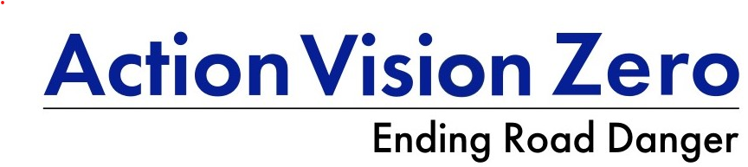
Speed enforcement, England and Wales (2024)
AVZ summary
June 2026

Key Points
- Speed enforcement reached a high of 3 million offences in 2024 in England and Wales (E&W).
- Speed limit offences dominate enforcement—they account for 86% of all motoring offences and are the most common offence sentenced at court (MoJ, 2026).
- Few police services in England are enforcing 20 mph, apart from London and Merseyside.
- DfT’s Road Safety Strategy did not prioritise speed enforcement but this is believed necessary to meet its ambitious casualty reduction targets (65% KSI and 70% child KSI decreased by 2035.
- All data is from the Home Office, except where noted.

Total
- 3 million speed limit offences in 2024 were reported in England and Wales (E&W),
- Speed limit offences accounted for 86% of all motoring offences reported. The next highest was Neglect of Traffic Direction (e.g. red light violations) which, at 138k, was less than 5% that of speed limit offences. (Both offences are almost all camera detected).
- The vast majority of speed limit offences are sanctioned out of court (90%) but are still criminal offences (unlike in the Netherlands).

Outcome
- The 3m does not include the 762k cancelled (20% of those initially reported).
Of the 3,028,022 speed limit offences (excluding cancelled) in 2024
- Over half (54%) were offered the National Driver Offender Retraining Scheme (NDORS). Whilst the driver pays for this course (avg £80-£100), they do not receive any penalty points. It can only be offered once in three years and part of the course fee is retained by the local police service/safety camera partnership to help fund camera operations.
- One-third received a Fixed Penalty Notice (FPN) – it is £100 and has not increased in a decade. The FPN does come with three penalty points on the driving licence.
- 10% were referred for court prosecution. The National Police Chief Council Guidelines state that speeding over a specified amount (e.g. 50mph in a 30 mph limit) must be dealt with at court.
- Of those that were convicted at court in 2024 (avg fine £221), very few are banned from driving (2%) and the ban is usually very short (under six months with 54 days suggested in the Sentencing Guidelines for speeding).

Trend by police service
- In E&W, speed limit offences were up 63% since 2014 and up 12% from 2023.
- 80% of the 43 police services reported an increase in speed offences since 2014, including a high of 922% in Devon and Cornwall.
- Since 2023, speed limit offences increased in 31 police services, including as high as 67% in Cambridgeshire.

Comparison per Killed and Seriously Injured (KSI)
- The national average was 111 speed limit offences per KSI.
- Excluding Warwickshire which had a very high rate (423), the range of speed limit offences per KSI ranged from a low of 20 in Kent to a high of 256 in Devon and Cornwall, meaning over 12 times as many speed limit offences sanctioned than in Kent.

Sources
HO (2026), Fixed penalty notices (FPNs) and other outcomes for motoring offences statistics
Police powers and procedures: roads policing, to December 2024
MoJ (2026), Criminal Justice Statistics quarterly: December 2025

